**Quantitative Growth Portfolio**

We have built the Quantitative Growth Portfolio using a simple construct: we use straightforward investment filters to identify thirty high-quality stocks and then leave the portfolio untouched for a year. Both in back-testing and in the live portfolios that we manage for our clients, we have found that this simple approach delivers consistently impressive results. In particular, the portfolio not only outperforms the benchmark set by BSE Sensex consistently, it also delivers healthy absolute returns and, more specifically, it performs extremely well when the broader market is experiencing stress.

Before we detail the returns delivered by the Quantitative Growth Portfolio, let’s explain the simple investment filters that we employ. To begin with, out of the approximately 5000 listed companies in India, we will limit our search to companies with a minimum market capitalization of Rs. 500 Crore, as the reliability of data on companies smaller than this is somewhat wavering. We then filter all Real Estate and Finance companies due to their complex nature making it hard to analyse quantitatively. This brings down our universe to a limited number of companies. To this universe we apply profitability factors and Rank them based on Capital efficiency metrics. The top 30 businesses are selected from the ranking and rebalanced annually.

A company deploys capital in assets, which in turn generate cash flow and profits. The total capital deployed by the company consists of equity and debt. ROCE is a metric that measures the efficiency of capital deployment for a company, calculated as a ratio of ‘Earnings before Interest and Tax’ (EBIT) in the numerator and capital employed (sum of debt liabilities and shareholder’s equity) in the denominator. The higher the ROCE, the better is the company’s efficiency of capital deployment.

Outperformance Table

|  |  |  |  |  |  |  |
| --- | --- | --- | --- | --- | --- | --- |
| **Start Date** | **Starting Balance** | **End Date** | **Ending Balance** | **XIRR** | **Sensex XIRR** | **Outperformance** |
| Jun-01 | 10,00,000 | Jun-11 | 1,21,96,090.91 | 28% | 20.50% | **8%** |
| Jun-02 | 10,00,000 | Jun-12 | 93,25,737.13 | 25% | 20.20% | **5%** |
| Jun-03 | 10,00,000 | Jun-13 | 1,05,50,665.21 | 27% | 20.20% | **6%** |
| Jun-04 | 10,00,000 | Jun-14 | 12,807,292.45 | 29% | 19.70% | **9%** |
| Jun-05 | 10,00,000 | Jun-15 | 11,986,668.13 | 28% | 16.10% | **12%** |
| Jun-06 | 10,00,000 | Jun-16 | 79,81,899.29 | 23% | 11.40% | **12%** |
| Jun-07 | 10,00,000 | Jun-17 | 75,44,666.15 | 22% | 9.30% | **13%** |
| Jun-08 | 10,00,000 | Jun-17 | 80,14,339.81 | 26% | 11.80% | **14%** |
| Jun-09 | 10,00,000 | Jun-17 | 76,84,636.35 | 29% | 11.50% | **18%** |
| Jun-10 | 10,00,000 | Jun-17 | 45,12,202.11 | 24% | 10.10% | **14%** |
| Jun-11 | 10,00,000 | Jun-17 | 37,16,043.84 | 24% | 10.30% | **14%** |
| Jun-12 | 10,00,000 | Jun-17 | 38,42,231.46 | 31% | 13.80% | **17%** |
| Jun-13 | 10,00,000 | Jun-22 | 63,69,822.00 | 22% | 11.70% | **20%** |
| Jun-14 | 10,00,000 | Jun-22 | 38,56,646.00 | 18% | 9.50% | **21%** |
| Jun-15 | 10,00,000 | Jun-22 | 23,41,118.00 | 13% | 9.52% | **14%** |
| Jun-16 | 10,00,000 | Jun-22 | 20,57,045.00 | 35% | 15.30% | **20%** |
| Jun-17 | 10,00,000 | Jun-22 | 16,98,905.00 | 11% | 11.11% | **0%** |
| Jun-18 | 10,00,000 | Jun-22 | 14,24,878.00 | 11% | 10.74% | **0.5%** |
| Jun-19 | 10,00,000 | Jun-22 | 18,46,055.00 | 23% | 10.14% | **13%** |
| Jun-20 | 10,00,000 | Jun-22 | 19,16,938.00 | 39% | 22.39% | **17%** |

Looking at the detailed back-testing of the Quantitative Growth Portfolio based on data going back to 2001 shows that such a portfolio beats benchmarks across all time periods. The portfolio also performs admirably well during stressful periods (like the Subprime crisis in 2008 and the Demonetisation period of 2016) when the overall stock market nosedived. This portfolio generates returns that are substantially higher than the benchmark as seen above.

In the next exhibit we have analysed the performance of these seventeen historical iterations of the Quantitative Growth Portfolio i.e. 200 years of cumulative portfolio investments. The median portfolio returns (compounded and annualized) has remained robust at around **28 per cent** historically, regardless of whether the investor’s holding period has been as short as one year or as long as ten years. Moreover, the Quantitative Growth Portfolio also delivers an extremely low level of volatility in these annualized returns for all holding periods—a necessary condition for investors to hold large exposure to equities in their net worth.

|  |  |  |  |  |
| --- | --- | --- | --- | --- |
|  | **1 Year** | **2 Years** | **3 Years** | **5 Years** |
| **Upper Band** | 182% | 93% | 69% | 53% |
| **Median** | 28% | 25% | 32% | 28% |
| **Average** | 33% | 30% | 28% | 26% |
| **Lower Band** | -56% | -19% | -10% | 11% |

In more technical terms, analysing the numbers behind the table above shows that over the past seventeen years, the Quantitative Growth Portfolio’s returns within two standard deviations have been positive for almost all holding periods and have been in excess of 11 per cent per annum for all holding periods of five years or more. In simple terms, it means that historical data suggests the Quantitative Growth Portfolio offers more than a 95 per cent probability of generating a positive return as long as investors hold the portfolio for at least three years.

**Why do we use ROCE?**

Charlie Munger, vice chairman of Berkshire Hathaway, stated in 1994, ‘Over the long term, it’s hard for a stock to earn a much better return than the business which underlies it earns.’ Munger meant that the returns generated by any company’s share price in the long term cannot be significantly more than the return on capital employed generated by the company in its day-to-day business.

Whilst there are several factors affecting short-term share price performance, earnings is the biggest driver of stock market returns in the long run. Thus we establish that it is more useful to see the firm’s ability to generate a decent Return on Capital Employed (ROCE).

Businesses are divided into three categories based on their returns:

1. High Earning businesses with low capital requirements.
2. Businesses that require capital to grow and generate a decent ROCE.
3. Businesses that require capital but generate low returns on capital.

The Quantitative Growth Portfolio is oriented towards the following themes taking into consideration the longevity and consistency of the ROCE performance:

* More B2C (Business to Consumer) companies than B2B (Business to Business) companies.
* More structure instead of cyclic plays.
* Avoiding companies that borrow loads of money to grow.
* Preference to companies with intangible strategic assets.

**Page Industries: A case study of ‘greatness’**

Page controls the master franchise of Jockey (innerwear and leisurewear) and Speedo (swimwear) in India. As shown in the exhibit below, over the past fifteen years, the firm has consistently achieved ROCE in excess of 15 per cent each year. In compounded annualized terms, over the past fifteen years, Page’s ROCE has averaged a staggering 55 per cent.

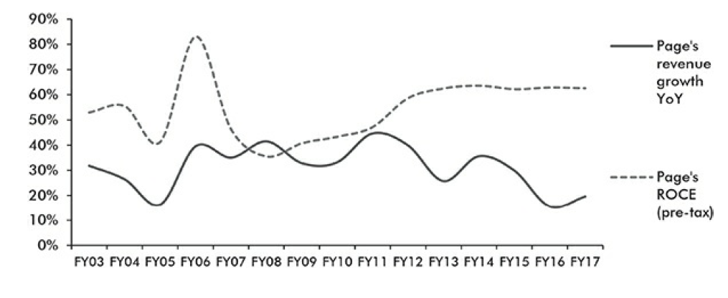

So, how has Page delivered such earnings growth over fifteen years despite operating with only a single brand in a single category, with competitors ranging from domestic incumbents to international players?

The product design, fit and fabric composition of an undergarment stock keeping unit (SKU) has to be indigenized in order to be successful in India. This is a curse if you get it wrong and a boon if you get it right. If a consumer accepts a particular style and brand, it is highly likely that she/he will stick to it. Therefore, consistency of product quality and design over a period of time across geographies is critical for a brand to avoid losing a satisfied consumer.

Finally, a steady stream of new products keeps distributors and retailers active and interested. Selling the same product year after year does get boring. Very few clothing brands have got all these factors right in India.

The firm has been very focused on deepening its moats for a very long time. Page’s journey with Jockey goes back to 1959. As a result, unlike many other promoters in India, who end up diluting their firm’s ROCE by misallocating surplus capital, Page has maintained strict capital allocation discipline over the past two decades. Page has been judicious while balancing the source of funding—between equity and debt—for its growth. Page makes apex decisions based on assessment of business growth and expansion. In its twenty-three years of operation, Page has consistently widened the gap between itself and competition and achieved steady market share gains without compromising on its pricing power.

‘Manufacturing prowess’ is Page’s biggest competitive advantage. Page’s approach to advertising has been unique on several fronts—high impact advertising campaigns, significant emphasis on in-store advertising, consistent use of Caucasian models in its advertisements (which firmly entrenched its brand recall as an ‘international brand’) and strict pricing discipline (no discounts).

Accessing Jockey’s innovations in the US and bringing them to a steadily growing market like India is a formula that has worked since 1995 for Page and should continue in the foreseeable future.

Credits: Coffee Can Investing by Saurabh Mukherjea

**Legal Information and Disclosures**

This memorandum expresses the views of the author and such views are subject to change without notice. Swan Capital has no duty or obligation to update the information contained herein. Further, Swan Capital makes no representation, and it should not be assumed, that past investment performance is an indication of future results. Moreover, wherever there is the potential for profit there is also the possibility of loss.

The information contained herein does not constitute and should not be construed as an offering of advisory services or an offer to sell or solicitation to buy any securities or related financial instruments in any jurisdiction. Certain information contained herein concerning economic trends and performance is based on or derived from information provided by independent third-party sources. We believe that the sources from which such information has been obtained are reliable; however, it cannot guarantee the accuracy of such information and has not independently verified the accuracy or completeness of such information or the assumptions on which such information is based.

This memorandum, including the information contained herein, may not be copied, reproduced, republished, or posted in whole or in part, in any form without the prior written consent of Swan Capital.